# HT Assignment – 5 (Meghanath P.)

## Task – 1: Database Design

1. Create the database named "TicketBookingSystem"

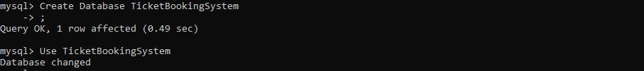

1. Write SQL scripts to create the mentioned tables with appropriate data types, constraints, and relationships. • Venue • Event • Customers • Booking



1. Create an ERD (Entity Relationship Diagram) for the database.

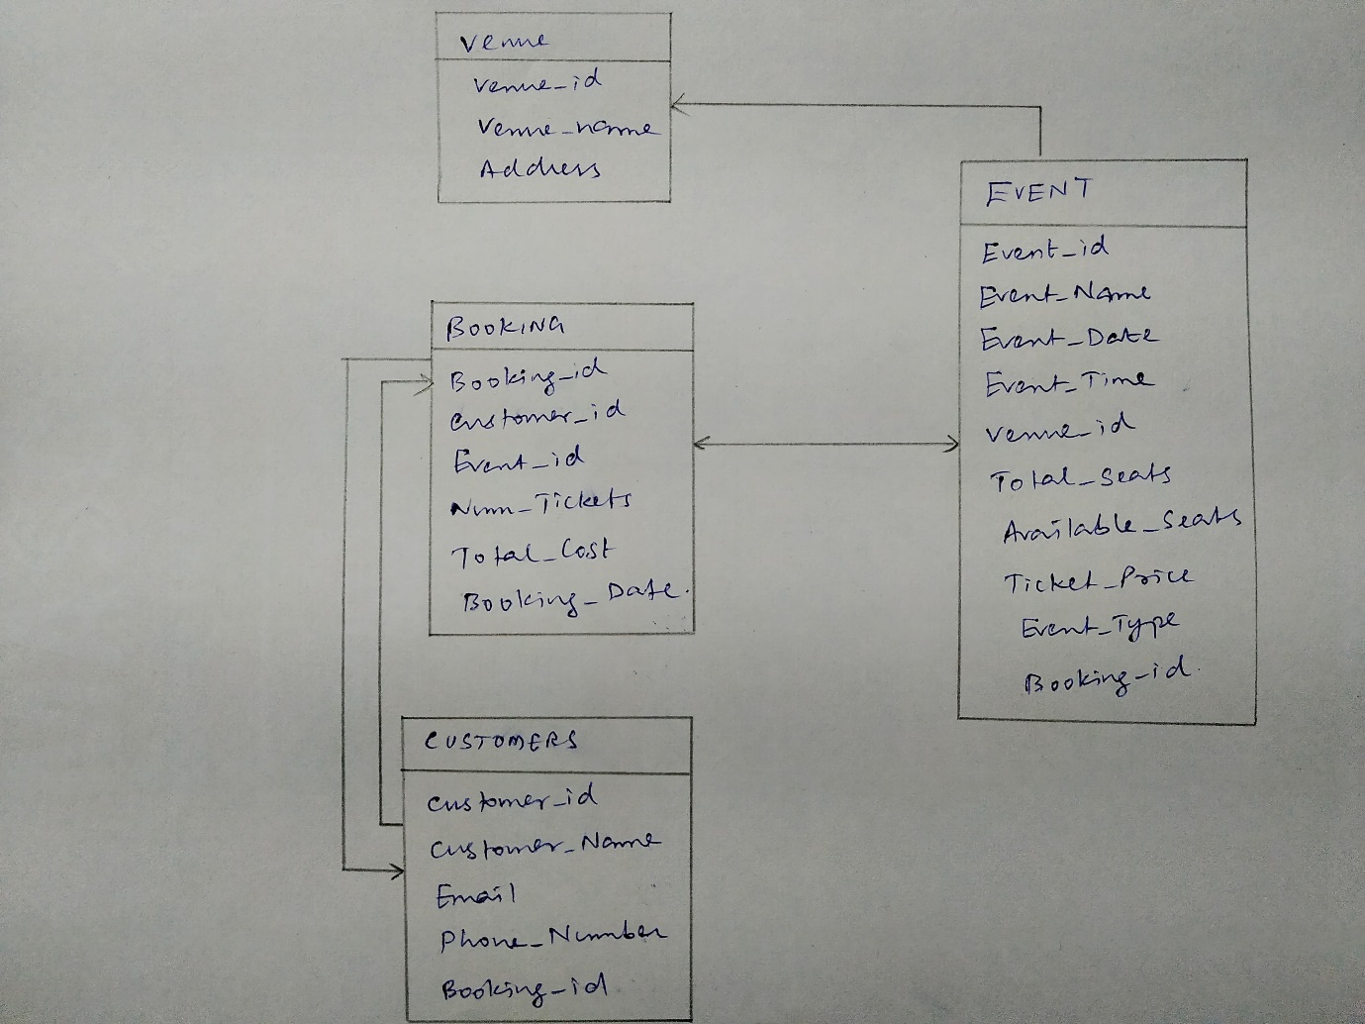

1. Create appropriate Primary Key and Foreign Key constraints for referential integrity

**(Already defined in the schema)**

## Task – 2 : Select, Where, Between, AND, LIKE

1. Write a SQL query to insert at least 10 sample records into each table.

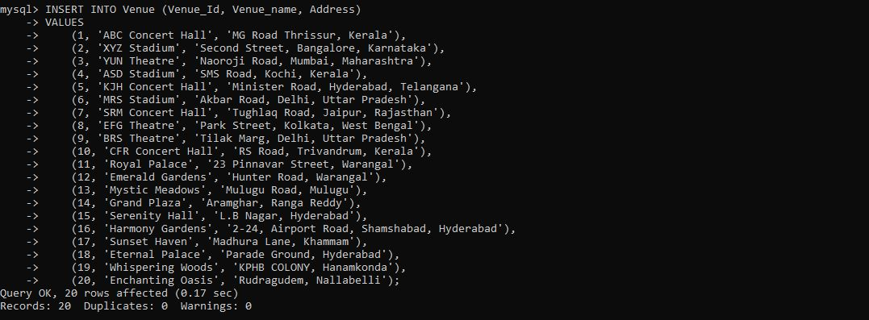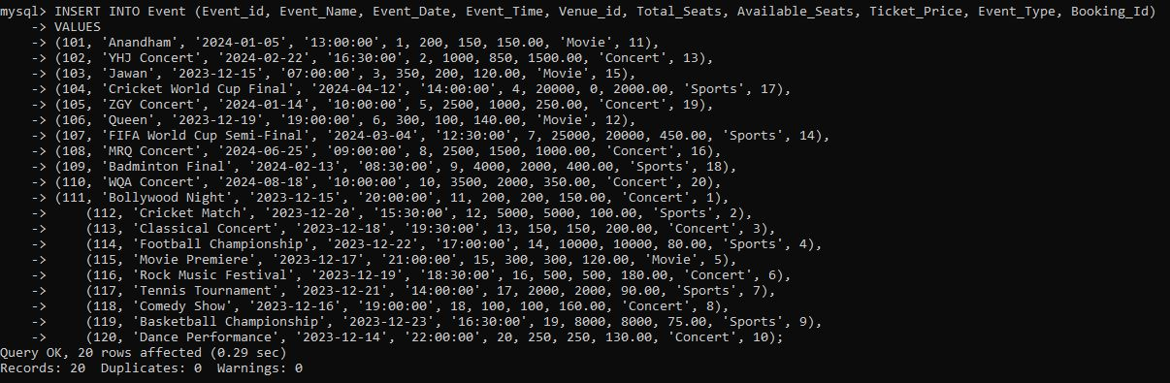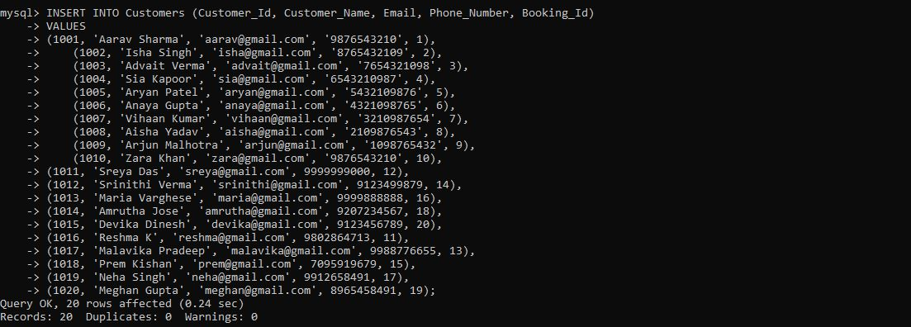

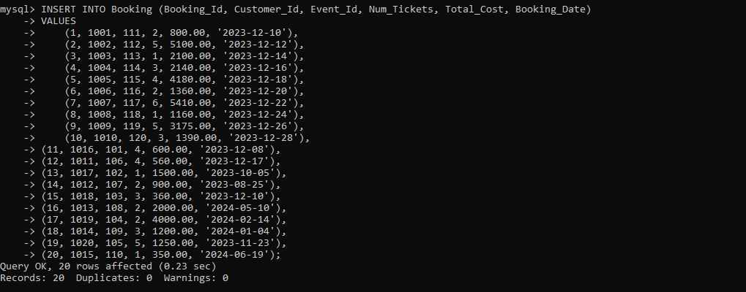

1. Write a SQL query to list all Events.

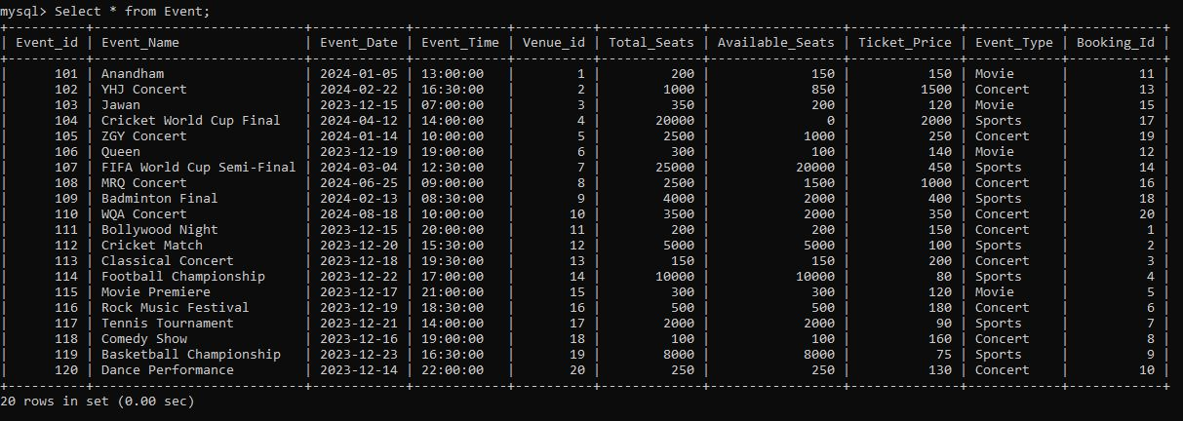

1. Write a SQL query to select events with available tickets.

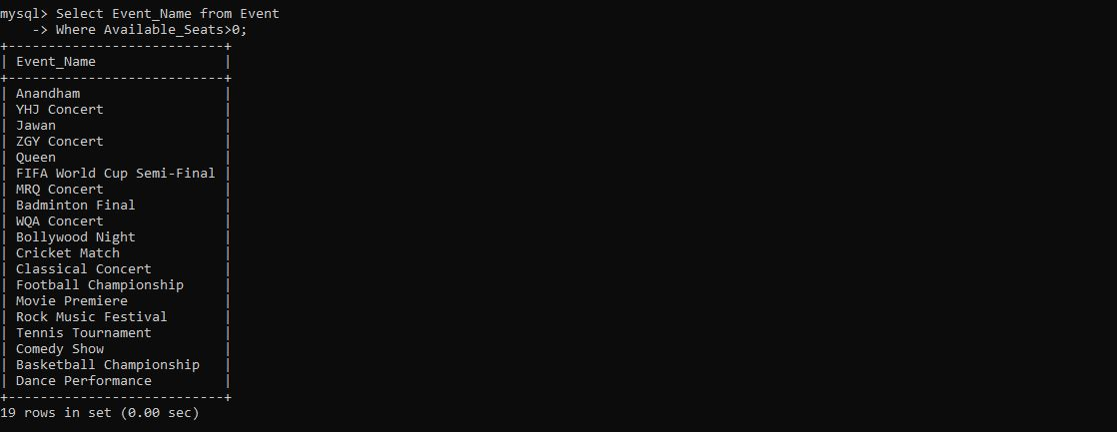

1. Write a SQL query to select events name partial match with ‘cup’.

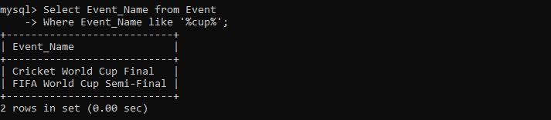

1. Write a SQL query to select events with ticket price range is between 1000 to 2500.

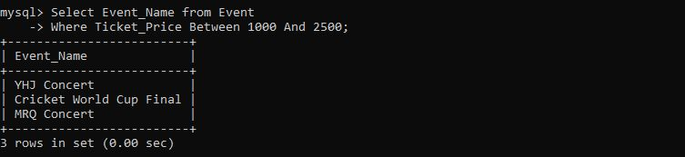

1. Write a SQL query to retrieve events with dates falling within a specific range.

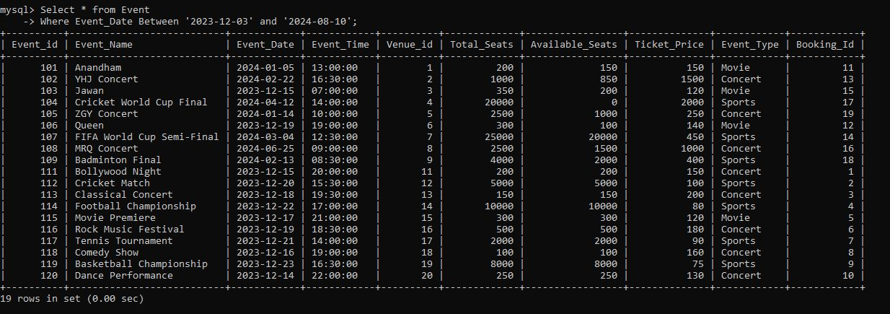

1. Write a SQL query to retrieve events with available tickets that also have "Concert" in their name.

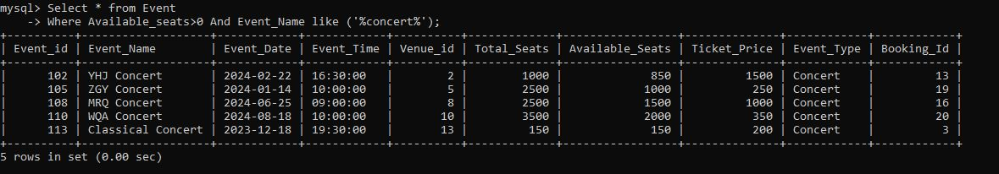

1. Write a SQL query to retrieve bookings details contains booked no of ticket more than 4

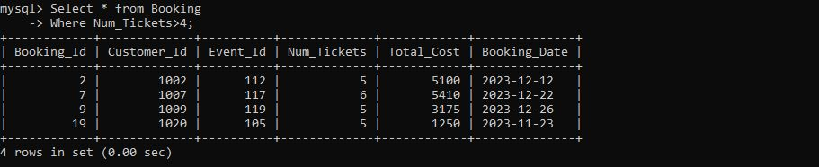

1. Write a SQL query to retrieve customer information whose phone number end with ‘000’

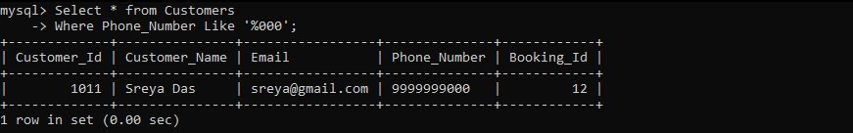

1. Write a SQL query to retrieve the events in order whose seat capacity more than 15000.

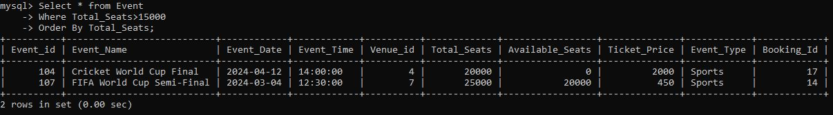

1. Write a SQL query to select events name not start with ‘x’, ‘y’, ‘z’

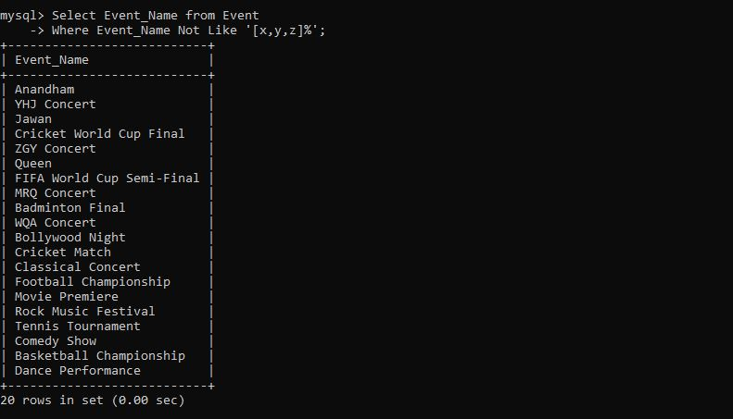

## Task - 3: Aggregate functions, Having, Order By, Group By and Joins

1. Write a SQL query to List Events and Their Average Ticket Prices.

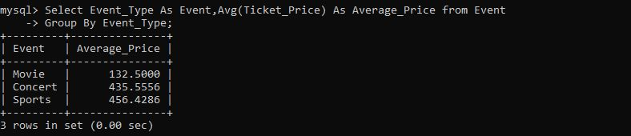

1. Write a SQL query to Calculate the Total Revenue Generated by Events.

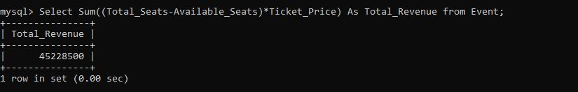

1. Write a SQL query to find the event with the highest ticket sales.

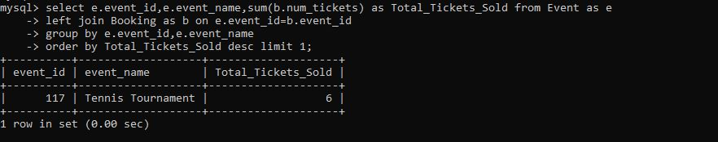

1. Write a SQL query to Calculate the Total Number of Tickets Sold for Each Event.

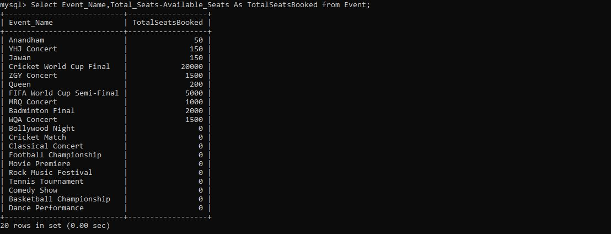

1. Write a SQL query to Find Events with No Ticket Sales.

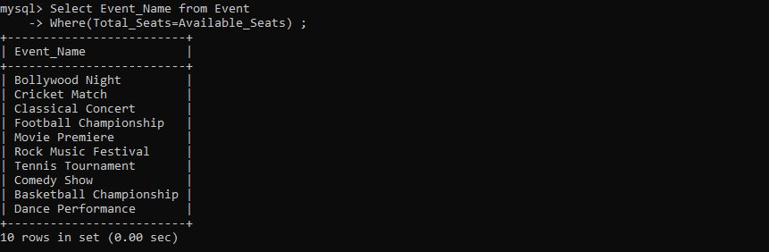

1. Write a SQL query to Find the User Who Has Booked the Most Tickets.

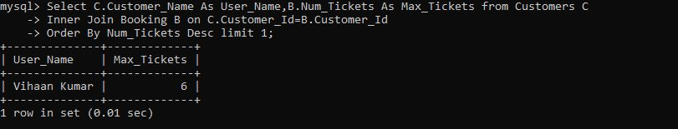

1. Write a SQL query to calculate the average Ticket Price for Events in Each Venue.

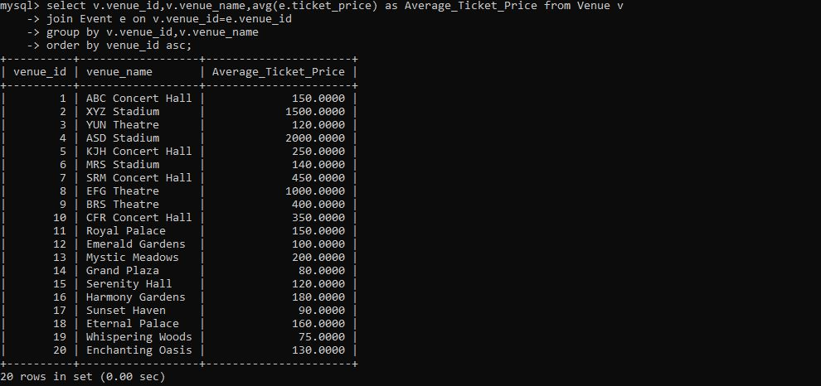

1. Write a SQL query to calculate the total Number of Tickets Sold for Each Event Type.

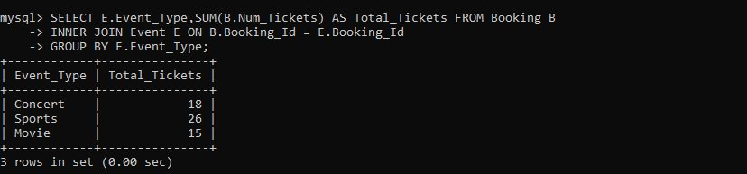

1. Write a SQL query to calculate the total Revenue Generated by Events in Each Year.

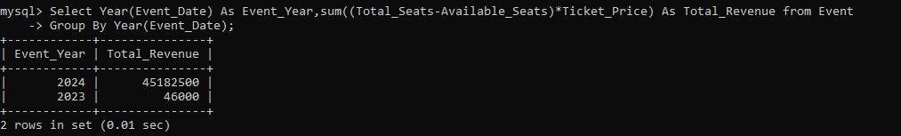

1. Write a SQL query to list users who have booked tickets for multiple events.

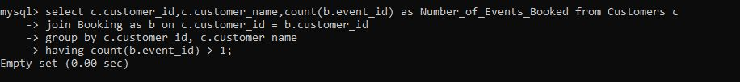

1. Write a SQL query to calculate the Total Revenue Generated by Events for Each User.

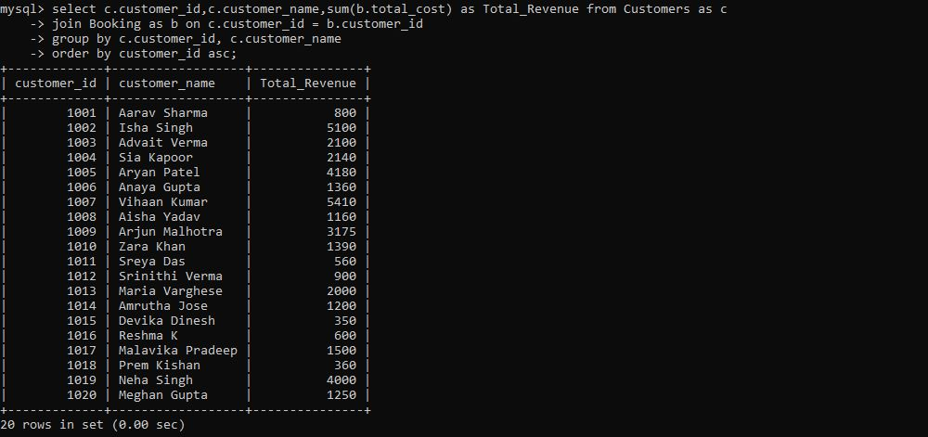

1. Write a SQL query to calculate the Average Ticket Price for Events in Each Category and Venue.

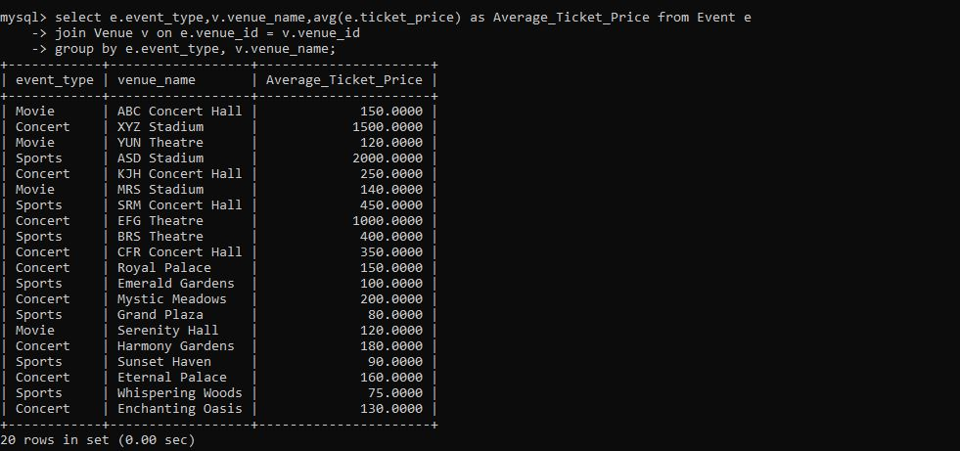

## Task - 4: Subquery and its types

1. Calculate the Average Ticket Price for Events in Each Venue Using a Subquery.

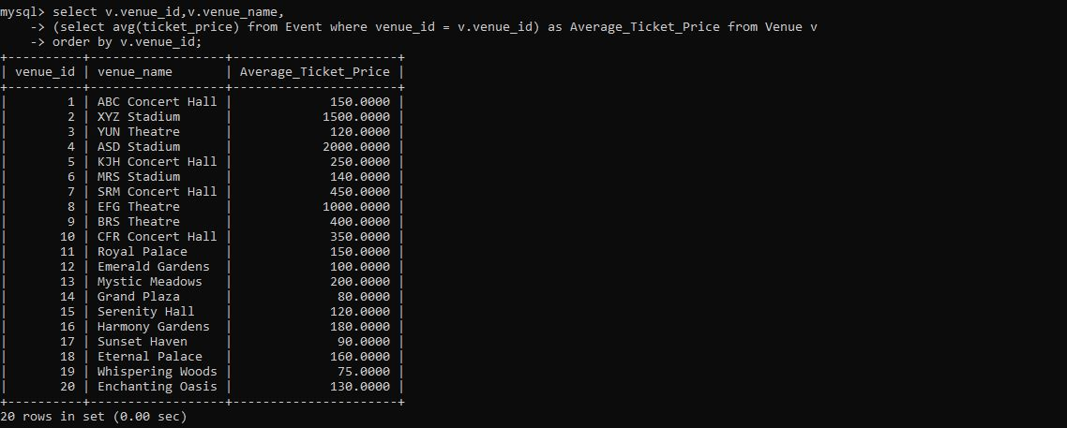

1. Find Events with More Than 50% of Tickets Sold using subquery.

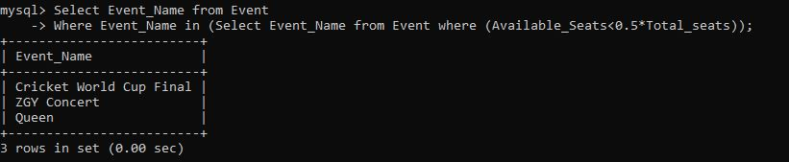

1. Calculate the Total Number of Tickets Sold for Each Event.

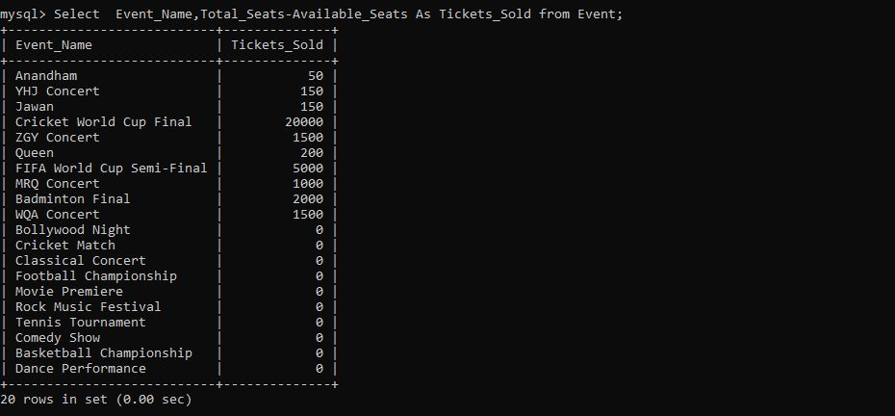

1. Find Users Who Have Not Booked Any Tickets Using a NOT EXISTS Subquery.



1. List Events with No Ticket Sales Using a NOT IN Subquery.

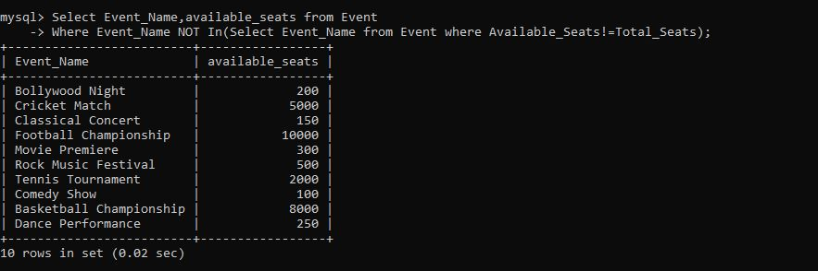

1. Calculate the Total Number of Tickets Sold for Each Event Type Using a Subquery in the FROM Clause.

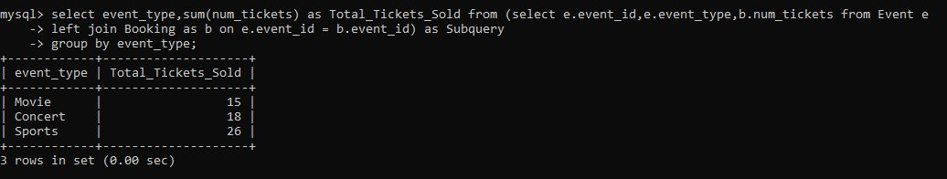

1. Find Events with Ticket Prices Higher Than the Average Ticket Price Using a Subquery in the WHERE Clause.

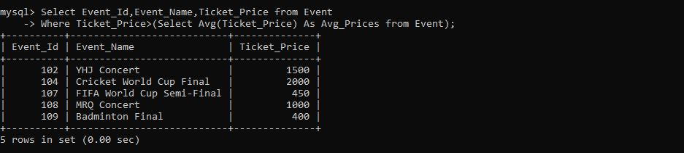

1. List Users Who Have Booked Tickets for Events in a Given Venue Using a Subquery in the WHERE Clause.

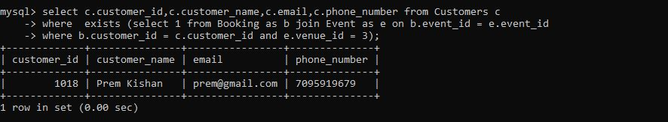

1. Calculate the Total Number of Tickets Sold for Each Event Category Using a Subquery with GROUP BY.

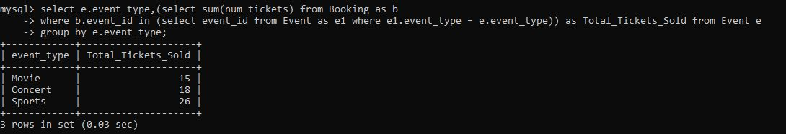

1. Calculate the Average Ticket Price for Events in Each Venue Using a Subquery

